Chapter 13, Problem 20.

Determine currents I₁, I₂, and I₃ in the circuit of Fig. 13.89. Find the energy stored in the coupled coils at t = 2 ms. Take ω = 1000 rad/s.

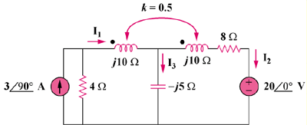

Figure 13.89
For Prob. 13.20.

